Chapter 4: Sound and light

4.1 Vibrating particles pass on sound

Student worksheet answers (pages 70–71)

Sound

1 How is sound created?

Sound is caused by the vibration of particles moving in a wavelike motion

2 Match the words in this table with their definitions.

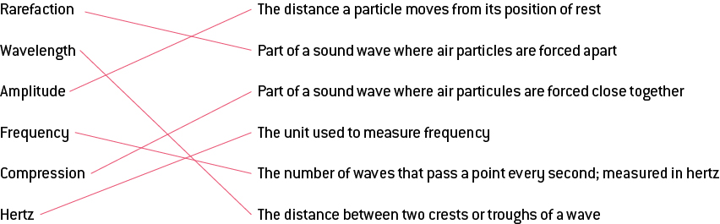

3 On the diagram below, label the areas that represent compressions and rarefactions.

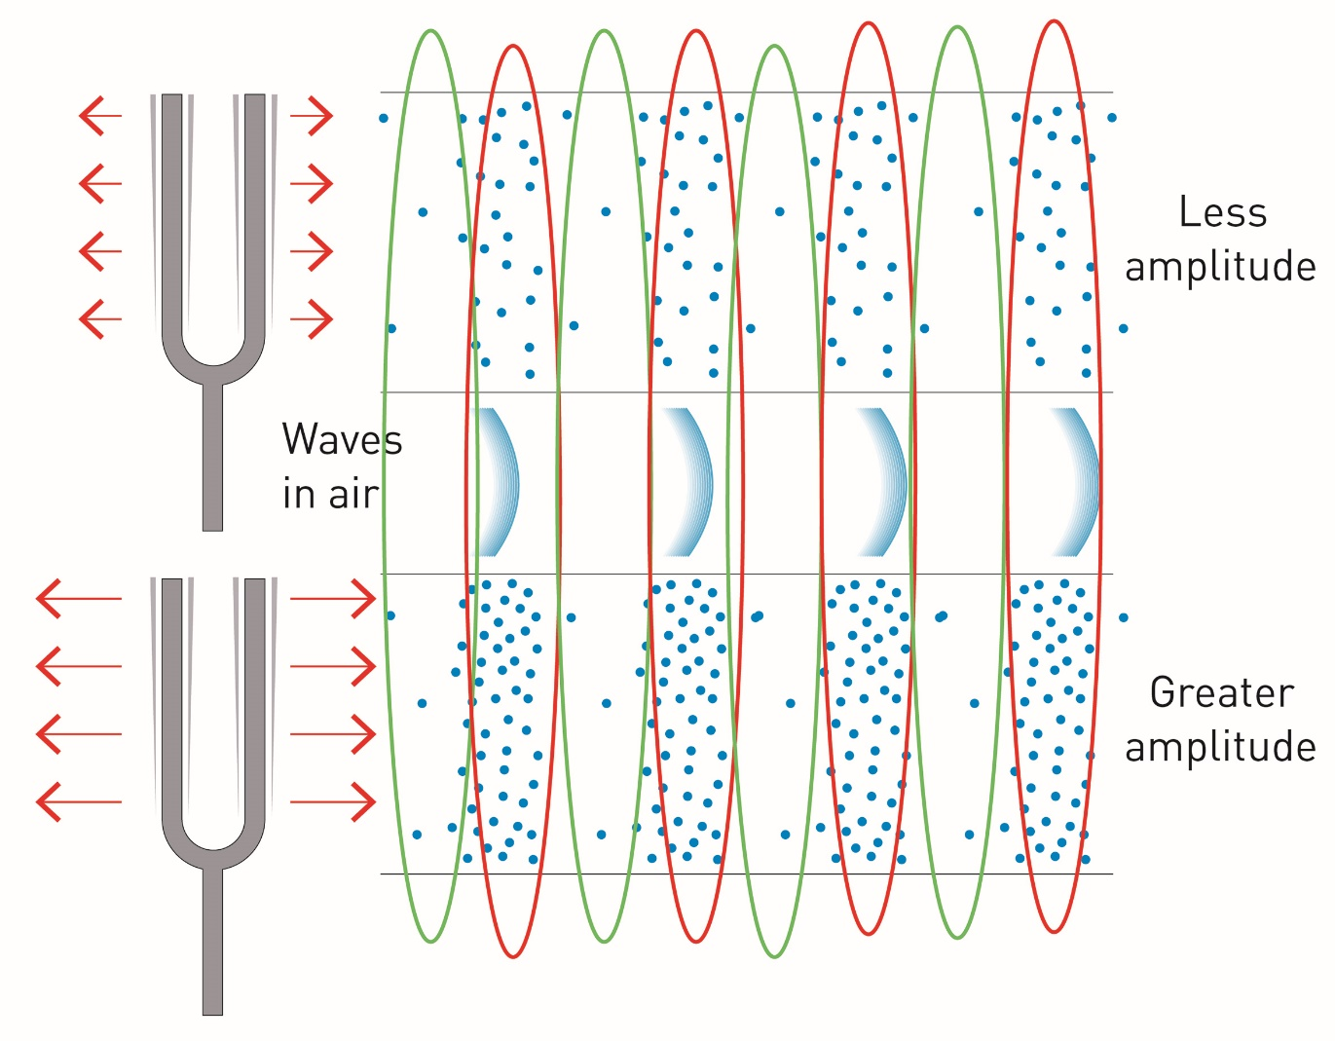

4 If you could see air particles, what would sound look like?

It would look like small dots moving closer together in one place and further apart in another. This pattern would continue until the particles lost energy and faded out.

5 Explain how the following are related to frequency, wavelength, compressions and rarefactions.

a high pitch

high pitch = high frequency = short wavelength = compressions and rarefactions close together

b low pitch

low pitch = low frequency = long wavelength = compressions and rarefactions are further apart

6 Of the following diagrams, label which would be high pitch, low pitch, high frequency and low frequency.

a

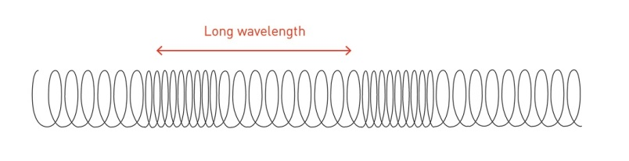

low frequency, low pitch, long wavelength

b

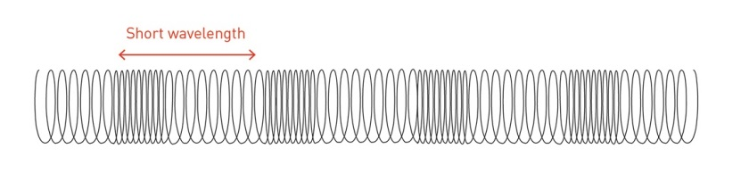

high frequency, high pitch, short wavelength

7 On the above diagrams, indicate where a wavelength would be and which has a greater wavelength.

EXTEND YOUR UNDERSTANDING

Men and women differ in the pitch of their voices. Conduct research about this phenomenon and answer the following questions.

8 What is the average frequency of male voices?

85 to 180 Hz

9 What is the average frequency of female voices?

165 to 255 Hz

10 Does a male or female voice have a higher pitch?

female voice

11 What is the biological cause of this difference in frequency and therefore pitch between male and female voices?

Men have longer vocal cords and women shorter. More vibration of these cords = higher pitch voice.

12 What is 'shimmer'? Explain this concept.

Females have a better chance of being able to reach a wider variety of pitches in their vocal range.

13 Biologically, what happens to a male voice in puberty to make the pitch decrease?

As the body goes through puberty, the larynx grows larger and thicker, causing vocal cords to lengthen

4.2 Sound can travel at different speeds

Student worksheet answers (pages 72–73)

The speed of sound

1 What is the speed of sound and under what conditions does this occur?

Sound travels at 340 m/s at sea level at 20°C.

2 Why does the speed of sound vary?

The medium that it travels through can vary in temperature, and the material through which it travels can change.

3 What happens to air as it increases in temperature?

Particles have more kinetic energy, so they can compress more easily.

4 What does this mean for sound at higher temperatures?

Sound travels faster at higher temperatures.

5 What is the relationship between particles and the speed of sound?

The more closely packed the particles, the faster the sound wave travels.

6 Does sound travel faster in water or air? Explain why.

It travels faster in water because particles are more closely packed together and thus transfer vibrations faster.

7 How fast does sound travel in space? Explain this.

Sound does not travel in space There are no particles to carry the vibrations so they cannot move from one place to another.

8 On 12 May 2013, Chris Hadfield, on board the International Space Station (ISS), released a music video of his rendition of ‘Space Oddity’ by David Bowie. How was he able to record this in space and have people hear what he was singing?

He was inside the ISS where there are gases that have a composition similar to the Earth’s. This means that when he sang, the vibrations were able to move to the recording device.

9 Complete the sentence: The more closely packed the particles in a solid ...

the faster sound travels through it.

10 In the table below, summarise the speed of sound.

|  |  |  |
| --- | --- | --- |
|  | Causes particles to: | Which means that sound will travel: |
| Increasing Temperature | increase kinetic energy, move faster and collide more often | faster |
| Making something more solid | increase the transfer of vibrations because particles are tightly packed | faster |

11 Explain how sonar works.

It sends out sound waves and records how long the sound takes to reflect or echo back after striking an object.

12 Provide 2 applications for sonar.

The time is takes to come back is relative to distance, so distances between submarines can be measured.

It can be used to map underwater structures.

EXTEND YOUR UNDERSTANDING

Many daredevils over recent years have dedicated a great deal of time and money to breaking the sound barrier.

13 What is the sound barrier?

It is the speed of sound 340 m/s.

14 What happens when you break the sound barrier?

You travel faster than the speed of sound.

15 Would it be easier to accomplish this in a plane or a car? Explain why.

It would be easier in a plane because planes are capable of moving at speeds much greater than cars.

16 You are travelling very fast in a convertible car and break the sound barrier. You decide to tell this to your best mate sitting beside you. Can your mate hear you? Explain your answer.

He can’t hear you because sound waves will travel behind you.

17 How fast does a commercial airliner travel? Is this faster or slower than the speed of sound?

878–926 km/h, which is much faster than the speed of sound.

18 Can you hear people talk to you when you are on a plane? Explain your answer.

The cabin inside the plane is pressurised, so the air stays in the cabin and cannot whip behind you, which means sound will travel as normal.

4.3 Our ears hear sound

Student worksheet answers (pages 74–75)

The structure and function of the ear

1 Label the structure of the ear

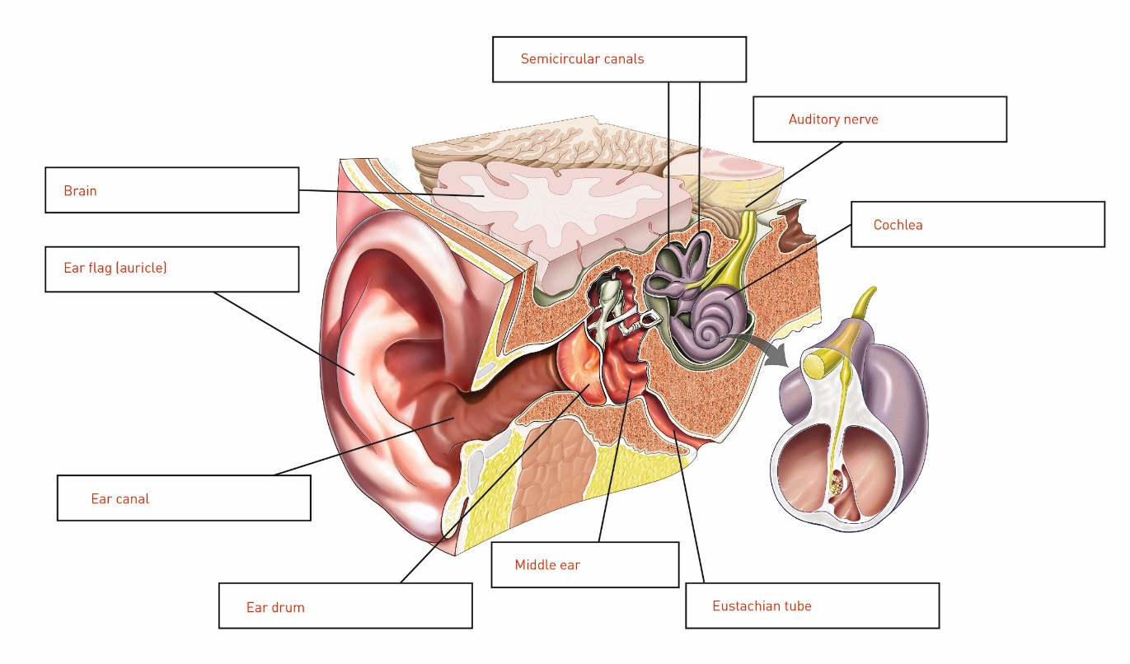

2 State the function of the 3 main parts of the ear and the structures belonging to each part.

a outer ear

sound waves are collected

consists of the auricle, ear canal and eardrum (outer layer only)

b middle ear

sound is amplified

consists of the eardrum, ossicles and oval window

cinner ear

sound is changed into an electrical signal and sent along the auditory nerve to the brain

consists of the cochlea

3 Match the following structure within the ear to its correct function.

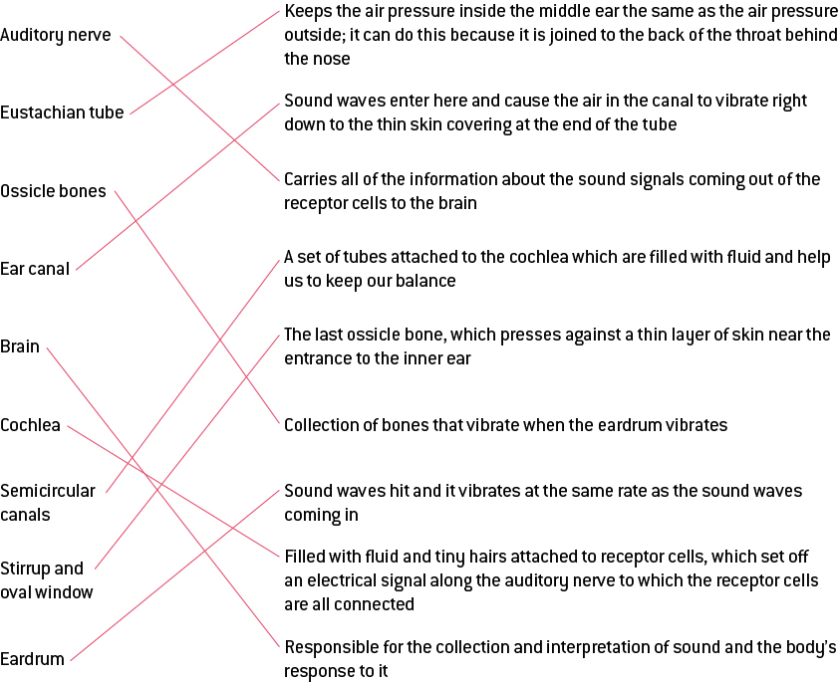

EXTEND YOUR UNDERSTANDING

4 Using as much of the sound terminology as you have learnt, explain the path that sound waves must follow through the ear and how they are converted into electricity before being transferred to the brain.

Air is vibrated in waves of compressions and rarefactions and travels through the ear canal before reaching the eardrum.

The vibrations tap on the ear drum, causing the ossicle bones behind it to vibrate in the same pattern. This presses against a thin layer of skin near the entrance to the inner ear called the oval window.

These vibrations then transfer to the cochlea, where they create waves in its fluid. These waves bend the little hairs that stick out of the receptor cells. The bending sets off an electrical signal along the auditory nerve to which the receptor cells are all connected.

This electrical signal travels through the auditory nerve to the brain, where it is interpreted according to its frequency and therefore pitch. High frequency = high pitch when waves are short and compressions/rarefacts are close together.

4.4 Science as a human endeavour: Things can go wrong with our hearing

Student worksheet answers (pages 76–77)

Problems with hearing

1 What does hearing rely on?

very thin layers of skin in the eardrum, small bones in the middle ear, and fine hairs in the cochlea

2 List 3 ways your hearing can become damaged.

loud noises

infections

age

3 How can the loudness of sound be measured?

using a sound level meter

4 What are decibels and what do they measure?

It is the unit (dB) that is used to measure the loudness of sound.

5 What is tinnitus?

a constant ringing in the ears that can be low or high pitched

6 What causes tinnitus?

loud noises, infections or drugs

7 What damage does this cause to the ear?

Exposure to constant loud noise can damage the small hairs in the cochlea.

8 What is the function of a hearing aid?

It increases the amplitude of sound waves as they move into the middle ear.

9 What is the difference between a hearing aid and a cochlea implant?

A hearing aid increases the amplitude of sound to make it louder, making it easier to hear.

The cochlea implant replaces an entire structure in the ear.

10 What is a cochlea implant?

It is a tiny electronic replacement for the damaged cochlea that does the job of healthy receptor cells.

11 What are the 2 sections of a cochlea implant and how do they work?

External part: consists of a tiny computer (the speech processor). It sits in a small case behind the ear and has a powerful built-in microphone. The speech is converted to electrical signals.

Internal part: receives the electrical signals that activate the hearing nerve inside the cochlea and send a message to the brain, just as healthy receptor cells would.

12 Why do you think that most people choose to have the cochlea implant in one ear, rather than both?

They may only have hearing damage to one ear or it may be too expensive. The main reason is that science may develop a cure for the natural cochlea, which they could not have if it had been removed for the implant.

EXTEND YOUR UNDERSTANDING

13 Choose one of the 3 hearing problems below and answer the following questions.

|  |  |  |  |
| --- | --- | --- | --- |
|  | Congenital deafness | Conductive hearing loss | Sensorineural hearing loss |
| In which auditory structure/s does the condition occur? | various | outer and middle ear | the cochlea or auditory nerve |
| What is the cause? | genetics, which are passed down by parents or it can happen in utero (before birth) | ear infections, perforated eardrum or blockage of the ear canal by wax or foreign objects | the ageing process, excessive noise exposure, diseases such as meningitis or Meniere’s disease, and viruses such as mumps or measles |
| What effects can it have on your hearing? | complete loss of hearing | leads to a loss of loudness | results in a loss of loudness as well as a lack of clarity |
| What is the treatment? | hearing aids may help, surgery if conductive hearing loss is present | medical or surgical means to unblock the ear | permanent and hearing devices are often recommended |
| Is there any way to manage the condition/limit ongoing effects? | none | clean ears, without pushing wax in, avoid excessive noise exposure | avoid excessive noise exposure and immunise against disease |

4.5 Visible light is a small part of the electromagnetic spectrum

Student worksheet answers (pages 78–79)

The electromagnetic spectrum

1 What is the electromagnetic spectrum?

It is a way of describing all the different forms of light, including the light we see

2 Which part of the electromagnetic spectrum do we see?

Visible light

3 How does light on the electromagnetic spectrum vary?

By wavelength and frequency

4 Compare and contrast light and sound waves.

Light is transverse wave (up and down), it is radiation

Sound is longitudinal wave (forward and back), it is the vibration of particles

5 Draw a light and a sound wave below to illustrate the main difference between them.

a Light wave

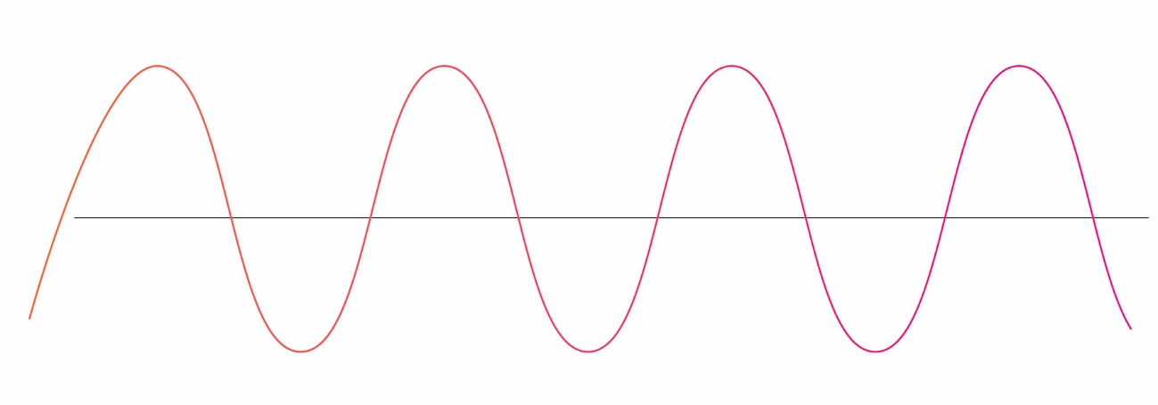

b Sound wave

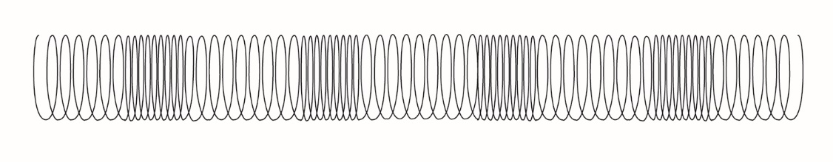

6 Label the wavelength (and identify it as long or short) and the amplitude of the following light waves.

a

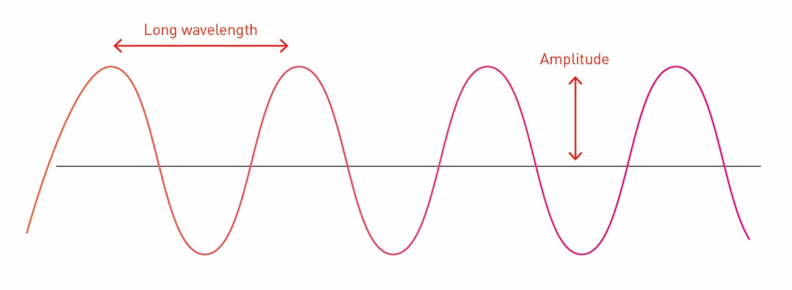

Low frequency, long wavelength

b

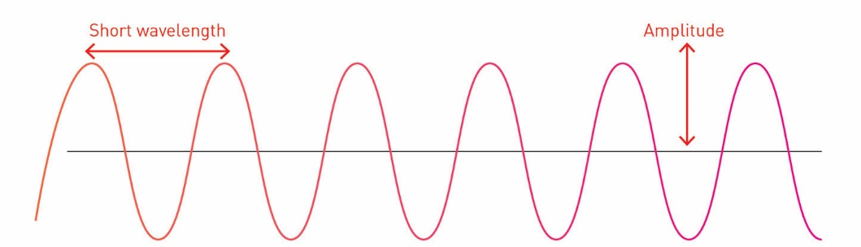

High frequency, short wavelength

7 On the diagram above, identify low and high frequency and what it is measured in.

8 How fast is the speed of light?

300 000 km/s

9 Why do astronomers say that when we look at the stars we are looking back in time?

Sometimes it takes thousands of years for light to reach Earth, so we see a star as it appeared thousands of years ago.

EXTEND YOUR UNDERSTANDING

In 1919, Edwin Hubble was working on the Hooker telescope in Los Angeles. He used a spectrograph to look through the telescope at the galaxies and could relate what he found to the Doppler Effect. The Doppler Effect is the change in frequency of a wave for an observer moving relative to its source. What this means is that if you are standing on a road and a car drives by you, it will sound different when it approaches, compared to when it is moving away.

10 When a car moves toward you do you hear a high- or low-pitch sound?

high-pitch

11 Is this high or low frequency?

high frequency

12 Does this frequency correlate to red or violet on the electromagnetic spectrum?

violet

13 When a car moves away from you do you hear a high- or low-pitch sound?

low-pitch

14 Is this high or low frequency?

low frequency

15 Does this frequency correlate to red or violet on the electromagnetic spectrum?

red

16 What did this imply, if the majority of galaxies that Hubble saw when he looked through the Hooker telescope were red?

It implies that the majority of the galaxies he saw are moving away for our galaxy.

17 If you rewound time, what would happen to these galaxies?

They would all move toward one another and crash into a central point.

18 What scientific theory did Hubble develop using this evidence?

This was evidence for the Big Bang Theory.

4.6 Light reflects off a mirror

Student worksheet answers (pages 80–81)

Reflection of light

1 Match the word with its definition below.

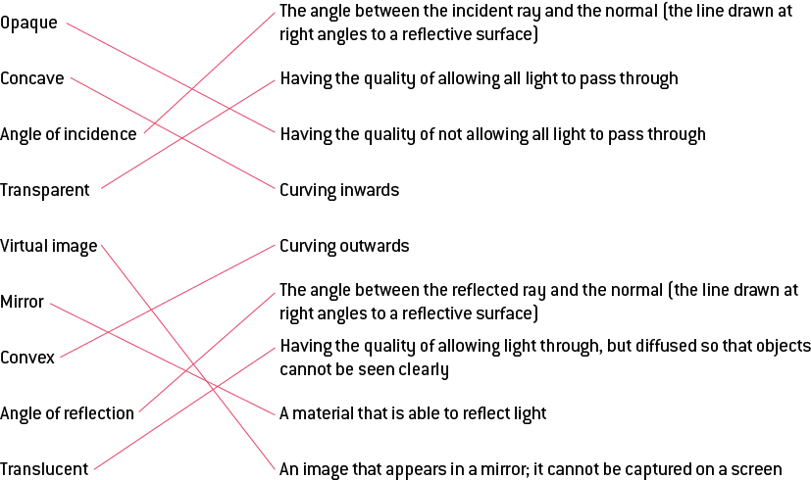

2 Name the quality and give an example of the type of object that will:

a let light pass through

transparent – glass

b block light

opaque – a brick wall

c only allow some light through

translucent – frosted glass

3 For the following mirror, draw the normal, the angle of incidence, the angle of reflection and label the incident and reflected rays.

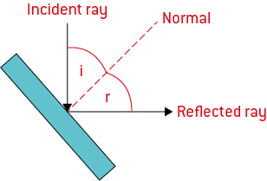

4 What is the relationship between the angle of incidence and the angle of reflection?

They are the same angle.

5 What do you see when you look in a plane mirror?

an inverted image

6 Draw a diagram of a concave and convex mirror in the space below and give a real world example of where they are used.

a concave

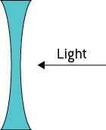

reflecting telescope

b convex

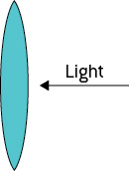

car passenger side mirrors

EXTEND YOUR UNDERSTANDING

7 Investigate reflecting telescopes and draw a diagram of a Gregorian and Newtonian reflecting telescope below. In both cases, label the incident and reflected rays and the mirrors involved, and explain how they work.

a Gregorian:

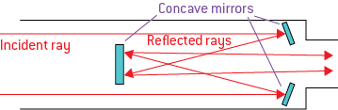

Consists of two concave mirrors; the primary mirror collects the light before the secondary mirror, where it is reflected back and out the bottom end of the instrument where it can be viewed.

bNewtonian:

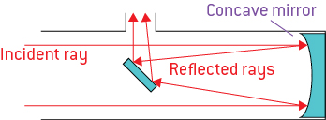

Consists of one concave and one regular mirror. The concave primary mirror collects the light and reflects it to the regular mirror, which reflects it again into the eyepiece on the side of the telescope.

4.7 Light refracts when moving in and out of substances

Student worksheet answers (pages 82–83)

Refraction of light

1 What is refraction?

the bending of light as it passes at an angle from one transparent mediuminto another

2 What is the result of refraction?

our view of an object is distorted

3 What does the bending of light depend on?

the optical density or refractive indexof the material and has the symbol *n*

4 On the following diagram, label the normal, incident ray, the angle of incidence, the refracted ray, and the angle of refraction

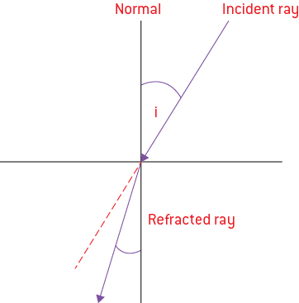

5 Is this form or refraction from water into air or air into water? Explain how you know.

It is from air into water. When a light ray enters a denser medium, such as from air into water, it slows down and consequently bends closer to the normal.

6 Explain how refractive index relates to density.

Dense liquids have a higher refractive index than less dense gases.

7 Why does light bend and how does this relate to a materials refractive index?

Light bends because it changes speed.

The lower the refractive index, the faster the light travels in the medium.

8 When is the only time that light does not bend?

Light does not bend when it enters a new medium along the normal (90° to the surface).

9 What is a lens?

It is usually a curved piece of transparent material, such as glass or plastic.

10 Draw a diagram of a concave and convex lens, demonstrating their convergence or divergence and focal length and focus point or virtual focus.

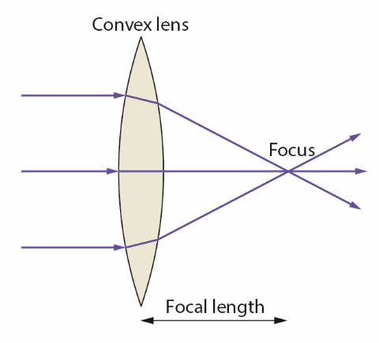

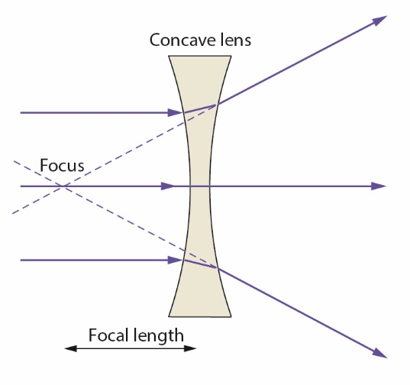

EXTEND YOUR UNDERSTANDING

11 Light bends and disperses when it passes into a prism and then back out into the air again. The refractive index of air is 1.0 and of the glass prism is 1.5.

a Why does light refract multiple times when moving through a prism?

The light will first refract from the air into the glass and then the glass into the air.

b What is dispersion and how does white light disperse?

It is the separation of white light into its different colours. White light disperses into a rainbow.

c Why does light disperse as it moves from air into a glass and then back out into the air?

Light waves travel at different speeds when they go from one medium to another (short wavelength is slower).

d Describe the direction that the light will bend (toward or away from ther normal) when it moves from the air into the glass.

As air is less dense it will move toward the normal

e Describe the direction that the light will bend (toward or away from ther normal) when it moves from the glass into the air.

Because glass is more dense, light will move away from the normal.

4.8 Different wavelengths of light are different colours

Student worksheet answers (pages 84–85)

Visible light is colour

1 What is dispersion?

It is the process of splitting white light into its component rainbow of colours.

2 Which colours does white light separate into? How can you remember these?

red, orange, yellow, green, blue, indigo, violet (ROY-G-BIV)

3 What is unique about each colour?

It has a different wavelength of light and will refract different amounts.

4 What is this range of colours called?

visible spectrun

5 What are primary colours?

They are the three that can be mixed to produce white light (RGB).

6 What are secondary colours?

a mixture of 2 primary colours (e.g., R + G = Y)

7 What are complimentary colours of light? How would you create them? Use the colour diagram to help you explain this.

When only two colours are needed to make white light, they are called complementary colours of light. They appear as opposite one another on the colour diagram. For example, cyan and red are opposite, so complimentary.

8 Which colours would you add to make white light if you started with the following:

a red

cyan

b blue

yellow

c green

magenta

d yellow

blue

e cyan

red

f magenta

green

9 Why do the leaves of plants appear green?

Red and blue wavelengths are absorbed.

The green wavelength is reflected back to our eyes.

10 Your boss hires you to grow a crop of plants and wants you to use optimal abiotic conditions only. What light would you use?

You would use magenta (red/blue) wavelengths because this is the one that is absorbed.

11 Determine which colours are absorbed and transmitted by cellophane which is coloured:

a blue

absorbs yellow (green/red), transmits blue

b magenta

absorbs green, transmits red/ blue

c cyan

absorbs red, transmits blue/green

dgreen

absorbs magenta (red/blue), transmits green

EXTEND YOUR UNDERSTANDING

12 At some point in your life, someone has probably told you that the sky is blue because if reflects the ocean, but this is not correct. Using the knowledge you have gained from pages 84 and 85, explain why the sky is blue.

The two most abundant gases in our atmosphere are nitrogen and oxygen, which scatter higher frequency and shorter wavelength portions of the visible light spectrum (violet then blue and green etc). Therefore, violet gets scattered the most and red (on the opposite end of the visible spectrum) passes through unseen. However, our eyes are also more sensitive to light with blue frequencies. Thus, we view the skies as being blue in color.

13 Just as the sky is blue, a sunset appears red. Using the knowledge you have gained from pages 84 and 85, explain why a sunset is red.

The lower frequencies of sunlight means it is seen as yellow light frequencies. It gradually turns colour as it approaches sunset because sunlight must travel further through more gases. This results in the scattering of greater amounts of yellow light. During sunset hours, the light passing through our atmosphere to our eyes seems to be most concentrated with red and orange frequencies of light. For this reason, the sunsets have a reddish-orange hue.

4.9 Science as a human endeavour: The electromagnetic spectrum has many uses

Student worksheet answers (pages 86–87)

Uses of the electromagnetic spectrum

1 What happens when light rays pass into a less dense medium at a very large angle?

It can be reflected back into the dense medium

2 What is this phenomenon called?

internal reflection

3 What are the applications for this phenomenon?

Cameras, microscopes and some telescopes use lenses, but several use prisms to reflect light.

4 What is a prism?

It is usually a triangular block of glass

5 What happens to light as moves into a less dense medium?

It is refracted away from the normal. Increase angle of incidence = increase refraction

6 What is the critical angle?

When the angle of incidence is refracted so much, it moves along the surface between 2 mediums (90ᵒ to normal).

7 What is an optic fibre?

It is a very thin fibre of glass or plastic that carries light.

8 What is the function of an optic fibre?

By sending the information as controlled pulses of light, a single fibre less than a millimetre wide can carry thousands of landline telephone calls.

9 What is the potential use of optic fibres?

communication systems – phone/Internet

10 What material will they end up replacing?

copper wires

11 What is the difference between what these two materials are able to do/carry?

Copper wires carry electrical signals and optic fibres carry light signals.

12 What are the advantages of optic fibres over copper wires?

There is less signal loss, greater carrying capacity and immunity to electromagnetic interference. They carry much more data, and crossed messages cannot happen. They don’t generate heat and can be used around high voltages.

13 How big are microwaves and what are they?

Microwaves are part of the electromagnetic spectrum. They are usually 1 mm to 1 m in length.

14 What are the applications of microwaves?

Microwaves have many uses, from communication (mobile phones) to cooking, from global positional systems (GPS) to radar.

15 How are they used for communication?

They can be focused into narrower beams than radio waves and used for personal or interstellar communication.

16 How are microwave ovens able to heat food?

Electromagnetic waves cause food and fat molecules to vibrate, creating friction and heat.

EXTEND YOUR UNDERSTANDING

17 The electromagnetic spectrum can be used in analytical chemistry to determine the structure of a chemical molecule. Conduct research on the following analytical chemical techniques and identify the type of radiation involved and what it is able to tell you about a molecule.

a infrared spectroscopy

uses infrared radiation; it identifies the functional group of a molecule; a functional group gives a molecule its properties e.g. alcohol or acid

b UV-visible spectroscopy

uses uv-visible radiation; it analysis the colour of a chemical to determine its concentration; the deeper the colour, the more concentrated the chemical

c hydrogen nuclear magnetic resonance spectroscopy

uses radio waves to determine how many hydrogens are in a molecule, what they are attached to and how many are on neighbouring atoms

d carbon nuclear magnetic resonance spectroscopy

uses radio waves to determine how many carbons are in a molecule and what they are attached to

4.10 Our eyes detect light

Student worksheet answers (pages 88–89)

The structure and function of the eye

1 Label the structure of the eye.

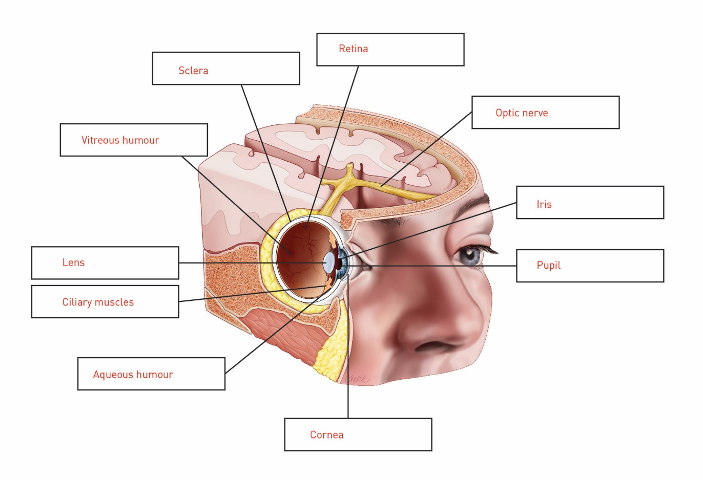

2 Match each structure within the eye to its correct function:

aqueous humour

cornea

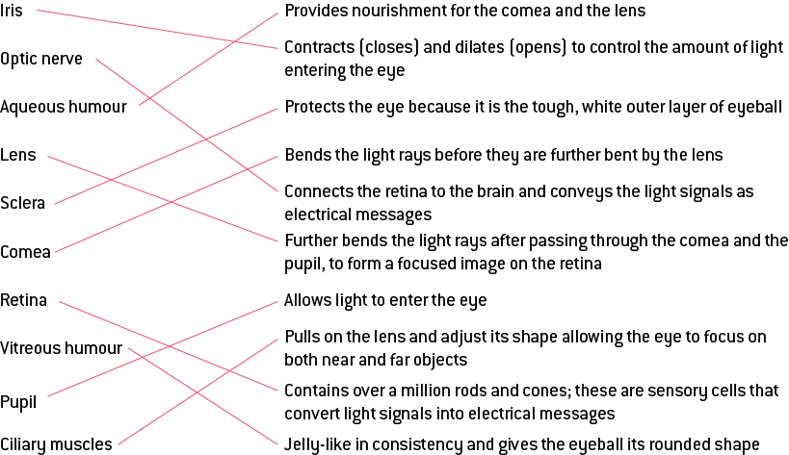

EXTEND YOUR UNDERSTANDING

3 Using as much of the light terminology as you have learnt, explain the path that light waves must follow through the eye and how they are converted into electricity before being transferred to the brain.

Light waves travel transversely into the eye through the cornea where light rays are refracted to ensure that they bend so that they pass through the aqueous humour (which nourishes the cornea and lens) and the pupil.

The lens, the coloured part of the eye, controls how much light passes from the cornea and through the pupil by expanding (to allow more light in) or contracting (to decrease the amount of light).

Light then travels to the lens where it is further refracted so that the light rays are bent toward each other. The ciliary muscles will manipulate the cornea to change shape and adjust so that the eye focuses light.

The image produced on the back of the eye, the retina, is upside down (inverted) and smaller (diminished) than the object. The retina contains light-sensitive cells called rods (sensitive to dim light) and cones (sensitive to colour). These cells detect light and convert it into an electrical signal, which is carried to the brain by the optic nerve. The brain then interprets the signals, turning them the right way and resizing them.

4.11 Science as a human endeavour: Things can go wrong with our eyes

Student worksheet answers (pages 90–91)

Problems with sight

1 What is myopia?

the ability to focus on near objects, with the inability to focus on distant objects

2 What is myopia described as?

short-sightedness

3 What causes myopia?

The eyeball is too long and the lens focuses the image in front of the retina.

4 How can myopia be treated?

Light rays need to be spread apart to refocus the image on the retina using glasses with concave lenses.

5 Draw a diagram of the eye focusing light rays before and after a lens is used (include the lense).

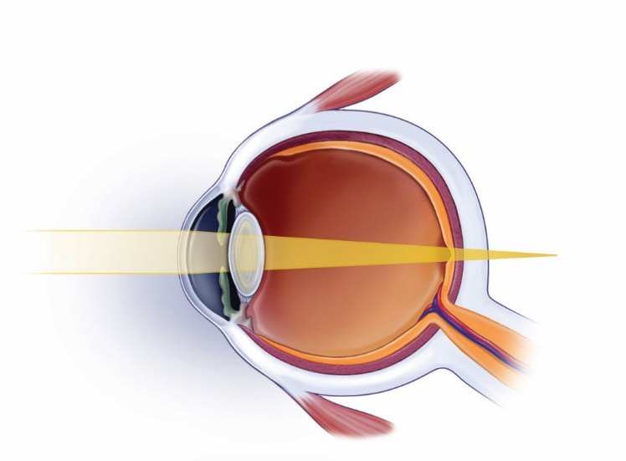

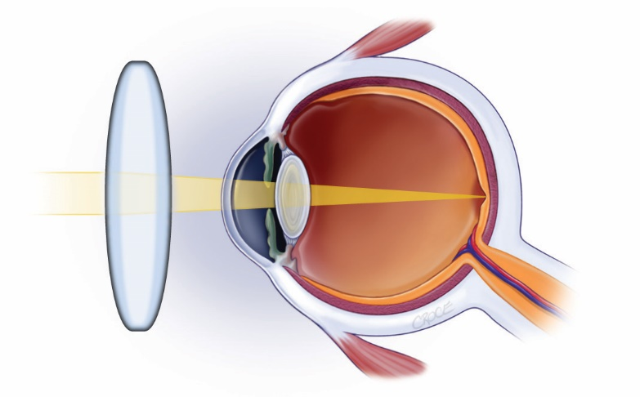

6 What is hyperopia?

the ability to focus on distant objects, with the inability to focus on near objects

7 What is hyperopia described as?

long-sightedness

8 What causes hyperopia?

The eyeball is too short and the lens focusrd the image behind the retina.

9 How can hyperopia be treated?

Light rays need to be drawn in closer together to refocus the image on the retina using glasses with convex lenses.

10 Draw a diagram of the eye focusing light rays before and after a lens is used (include the lens):

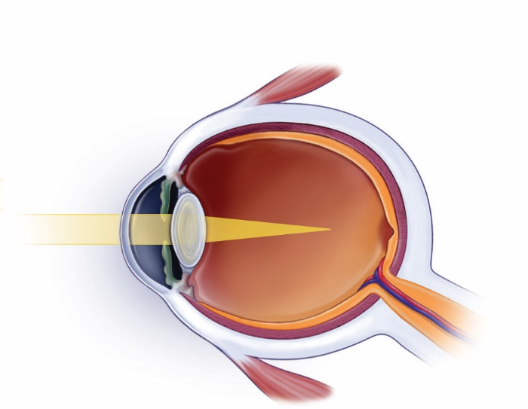

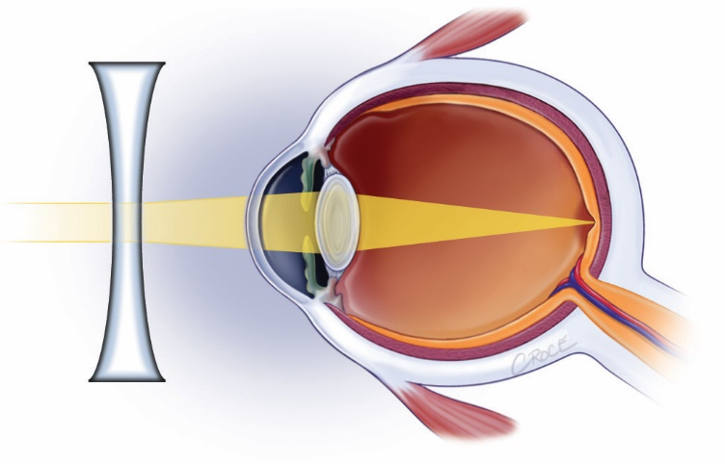

11 What is the cause of colour blindness and what is the effect?

The cone cells do not function correctly. This causes an inability to tell the difference between certain colours.

12 What is the cause of cataracts?

The lens in the eye can start to become cloudy to the extent that it can eventually frost over, like frosted glass.

13 What do cataracts lead to?

total blindness

14 How can cataracts be treated?

The cataract lens can be removed in eye surgery and replaced with a plastic multifocal lens.

15 What is the cause of astigmatism?

The cornea is oval shaped rather than circular.

16 What can astigmatism lead to?

an inability to focus correctly and, therefore, blurry vision

17 How can astigmatism be treated?

with prescription glasses

EXTEND YOUR UNDERSTANDING

18 Choose one of the 3 vision problems below and answer the questions that follow.

|  |  |  |  |
| --- | --- | --- | --- |
|  | Esotropia (mistakenly called lazy eye) | Glaucoma | Pterygium (surfers eye) |
| In which visual structure/s does the condition occur? | one or both eyes become crossed; affects whole eye | eye disorders that all cause damage to the optic nerve | an elevated, wedged-shaped bump on the eyeball that starts on the white of the eye (sclera) and can invade the cornea |
| What is the cause? | the cause of infantile esotropia is unknown; we know there is an inability to use the two eyes together; hypotheses include both sensory and/or motor dysfunction | higher-than-normal pressure inside the eye | – ultraviolet radiation from the sun  – dust and wind are sometimes implicated too |
| What effects can it have on your sight? | – decreased vision  – decreased depth  – perception  – crossing or inward  – deviation of the eyes, often intermittently at first. | if untreated or uncontrolled, glaucoma first causes peripheral vision loss and eventually can lead to blindness | it can distort the shape of the front surface of the eye, causing astigmatism |
| What is the treatment? | – glasses reduce the focusing effort and convergence of the eyes and can straighten the eyes  – eye drops, ointment, or special lenses with prisms added can also be used to straighten the eyes.  – surgery is possible | glaucoma surgery, lasers or medication, depending on the severity; eye drops with medication are usually tried first to control glaucoma | depends on severity:  – lubricants or a mild steroid eye drop  – topical ointments  – surgery to excise the growth |
| Is there any way to manage the condition/ limit ongoing effects? | children are born with this and it is unknown as to why; there is no way to avoid it only to follow treatments to straighten the eyes | recent research suggests exercise, but there is no fool proof prevention technique | – wear sunglasses to protect the eye.  – once you have it, it tends to recur |